Name: Farwa Ahmad

Roll number: MCSF19M024

Subject: Mobile Computing Week 2

# Lecture 3,4 – GitHub.com

* Merge conflicts:

Same file is edited in different ways on central and local repositories.

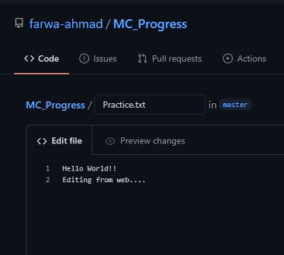

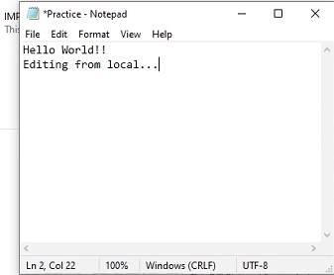

On trying to commit and push changes, we will receive the following:

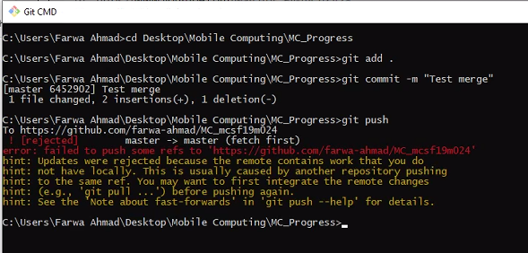

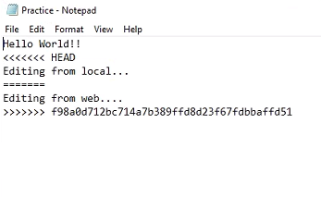

Now edit the file to choose what to commit.

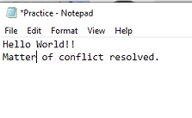

Now commit and push



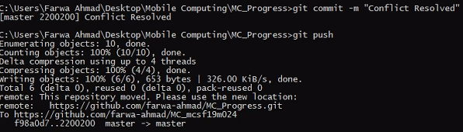

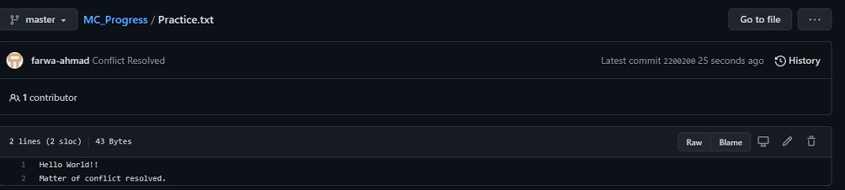

* Git log

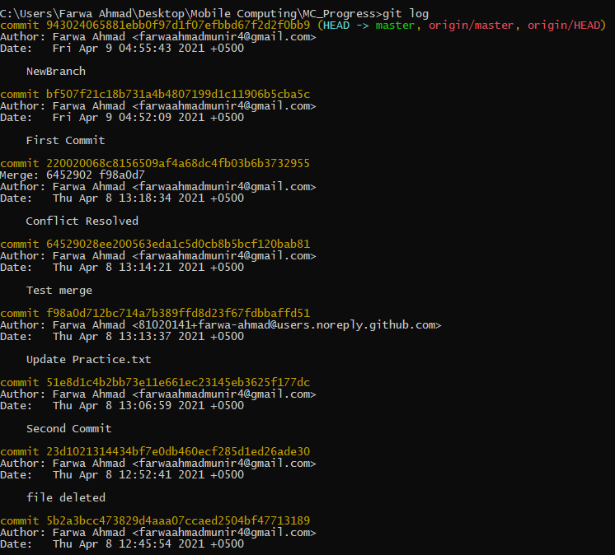

* Remove files from central repository

git rm [file name]

git add .

git commit

git push

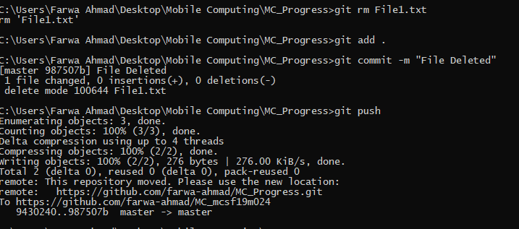

* Branching
  + To fetch information about branches: git branch
  + To create and navigate branches: git checkout -b [new branch name]
  + To merge a branch with the current branch: git merge [branch name]

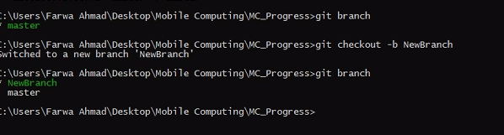

In the above picture we are in NewBranch, therefore now whatever changes we make to our file they will be specific to this branch.

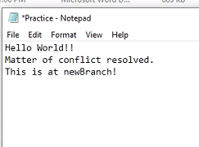

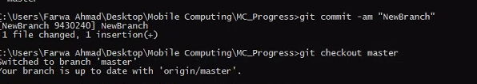

Now if we checkout to master branch in this reference, we will see that the file does not have the changes we made in NewBranch

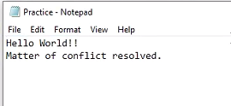

Now merging branches:

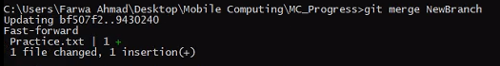

* + 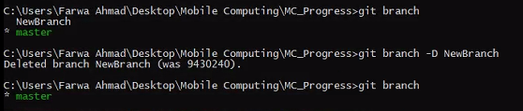Delete a branch: git branch -D [branch name]